Shining Light Galway

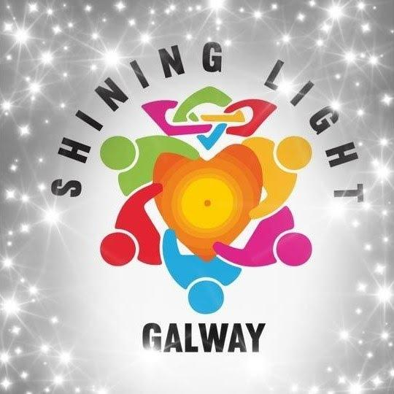

Volunteer Application Form
Private and Confidential

Notes prior to completion:
Please complete all sections of this application, as well as signing all Declarations. Failure to do so, may result in your application being returned. Due to the sensitive nature of our work, we can only accept applications from those aged 18 AND OVER.

The contents of this application are strictly confidential and not disclosed to any third party.
By returning these forms you are agreeing to allow your personal information to be stored by Shining Light Galway for a period of no longer than 12 months unless you are accepted as a volunteer, where they will be stored on your HR file.

1 COLOUR PASSPORT PHOTOs MUST ALSO ACCOMPANY THIS APPLICATION.
Please complete this form in BLOCK CAPITALS
ALL SECTIONS ARE COMPULSORY.

PERSONAL DETAILS

Full Name: __________________ _____________________________________________________________

Postal Address: ____________________________________________________________________________

_________________________________________________________________________________________

Date of Birth (DD/MM/YYYY)

Age:

Mobile:
Email Address:

Next of KIN: Name: ____________________________________________

Next of KIN: Phone: ___________________________________________

Have you any Medical Conditions we should be aware of? (If so, please state clearly):

(Use a separate sheet if necessary)

___________________________________________________________________________

DUTY NIGHTS

Please circle which days you are available for Volunteering:

*Volunteers are not asked to do more than TWO day a week, however, may do more if they wish.
*Circle more than one day if you wish.

Monday 10am-6pm
Tuesday 10am-6pm
Wednesday 10am-6pm
Thursday 10am-6pm
Friday 10am-6pm
Saturday 10am-6pm

Please indicate the frequency you feel you would be able to Volunteer;
(We understand this may change due to people’s personal circumstances etc.):

FREQUENCY [please tick (✓)]
Once a Week
Once a Fortnight
Once a Month
Minimum requirement is once per month

Volunteers will also be required to participate in Training courses on various dates, separate and in addition to their patrol availability. Notifications on these courses will be sent out regularly.

Garda Vetting
All applicants are submitted for Garda screening. The National Vetting Bureau (Children and Vulnerable Persons Bill 2012) makes it mandatory for persons in contact with children or vulnerable adults to be vetted by Gardaí. A Garda Authorised ‘Volunteer Centre’ deals with our requests to vet prospective Candidates and we have no control over the speed or results of this screening. An ‘Invitation to Vetting’ form NVB1 follows this application form and therefore must be also completed. There is a €10 fee for vetting. Please enclose with application.

Disclosure of Details
Due to Data Protection, we cannot disclose any details about unsuccessful applications, such as why they failed or if it was due to Garda Vetting etc. – so please do not ask, if your application is unsuccessful.

Medical Disclosure
Due to the nature of our work and some aspects of training, an acceptable normal level of fitness is required, as our Patrols can involve a considerable amount of walking (at a leisurely pace). Shining Light Galway will not be held liable for any aggravation or recurrence of injuries/illnesses which occur during or after activities /training and which were not disclosed at this point.

(Please circle below:)
- Have you had experience of Suicide/Self Harm in your life? YES NO
(Friend/Family member/Colleague/Unrelated

If YES, please outline; ____________________________________________________

- Are you presently on any medication/treatment? YES NO

If Yes, please outline; ____________________________________________________

- Do you suffer from any Physical or Mental conditions? YES NO

If YES, please outline; ___________________________________________________

- Have you experienced any signs or symptoms of any Medical Problems (or Mental Illness problems) in the past, regardless of whether any Healthcare Professional had been consulted or not? YES NO

If YES, please outline; _____________________________________________________

- Do you require or expect to require any review, investigation or treatment for any current or past medical conditions? YES NO

If YES, please outline; _____________________________________________________
If you have answered YES to any of the above, further details may be required at a later date if your application is successful. In other cases, we may just require a letter from your doctor.

ADDITIONAL INFORMATION
‘’ABOUT YOU’’
In a few lines, tell us WHY you wish to Volunteer with Shining Light Galway

Do you have any official qualifications/experience that may be of benefit to the Team? (CPR/PHECC/SafeTALK/Asist/VHF Radio etc)

(Please note any ‘Formal’ qualifications such as First Aid, SafeTALK, ASIST, QPR, Water Safety etc MUST be backed up by a copy of the relevant Certificate, including expiry date – and provided to us if your application is successful.)

Do you know any existing Volunteers? YES NO
If YES, please state their Name and indicate relationship to this person – e.g. Relation, Friend, Colleague etc:

Would you be happy for this person to give you a Character Reference? YES NO

What qualities or skills do you feel you can bring to our Team? (Fundraising/Networking/Admin/Logistics etc)

OTHER INFORMATION

Please note that as part of your remit as a volunteer, you will be required to participate and/or attend at some fundraising events occasionally.

Promotion and fundraising opportunities are available within the organisation, there are various other roles carried out by our volunteers.

Applicants are subject to a ‘Settling In’ period for 12 months and are subject to ongoing appraisals.

Confidentiality must be strictly adhered to at all times. Volunteers are asked to be cautious about passing on ANY information via Social Media such as Facebook, Twitter or Instagram – this organisation has a strict policy on social media, a copy of which is available from the Committee. We have an official Facebook page where people should be referred to for more information. All inquiries should be directed through the Shining Light Galway phone no. 087 3338800 or email: support@shininglightgalway.org

The organisation has a ‘Private’ Facebook group, which all successful candidates are added to after their first patrol. This is used to keep volunteers updated with the latest information, events and rosters. Details will be provided.

You will be notified well in advance of patrol responsibilities and times so ensure you provide your latest email address and check regularly for correspondence.

Each successful candidate will receive a Volunteer Agreement Form, Applicant Declaration Form and Confidentiality Agreement Form.

Copies of all qualifications can be sent to support@shininglightgalway.org 2 Passport photos should be supplied by applicant prior to induction.

APPLICANT DECLARATION

‘’I do hereby declare to Claddagh Watch, that I do not possess any Criminal record and have not been charged with any criminal offence in Ireland or abroad – nor have any cases pending. I understand and accept that any such charge or offence(s) uncovered during Garda Vetting will result in refusal of my application.

Upon acceptance I hereby agree to be bound by all Protocols, Rules & Regulations, Codes of Conduct, Volunteer Agreement, Confidentiality Agreement, Health & Safety Procedures, and Standard Operating Procedures as outlined by the organisation and agree to follow any guidelines or additional instructions that may be issued to me from time to time.

I will make every effort to uphold the good name of the organisation and will not do anything to bring the organisation into disrepute or to put the safety of any other volunteer at risk. I further agree to attend any training courses requested of me within a reasonable period and make every possible effort to attend any Patrols, meetings or exercises that are scheduled by the organisation.

I will commit to make myself available to the organisation for volunteering in accordance with the times/dates specified in my application and also try to assist when additional people are needed from time to time.

I finally confirm that the information given by me in this application is complete and accurate and I have attached a recent Passport Photo’’

SIGNED: ………………………………………………………………………………………………………………………………………

NAME: …………………………………………………………………………………………………………………………... (PRINT)

DATE: …………………………………………………………………………………………………………………………………………
Additional Notes you wish to bring to the attention of Shining Light Galway (if any):
___________________________________________________________________________________________________________________________________________________________

